Centenary Baptist Church CMS
Phase 6 — Step 12: Final Production Verification & Security Audit
Generated: 29 September 2026 | Project: centenary-baptist-church | Auditor: Antigravity IDE
Security
:

PASS
Database
:

PASS
Backend
/
API
:

PASS
Frontend
:

PASS
CSP
:

WARNING
SEO
:

WARNING
3

Manual

Actions

Required
⚠

PENDING

MANUAL

ACTION
—
Donation

QR

Code

Migration
The

donation_config

Supabase

table

exists

and

the

backend

code

correctly

reads

from

it
,
but

the

existing

QR

code
has

not

yet

been

migrated

from

local

storage

to

Supabase

Storage
.
You

must

re
-
upload

the

QR

code

image

via
Admin

Dashboard

→

Donations
to

complete

the

migration
.
Until

then
,
the

public

Give

page

will

display

no

QR

code
.
1. Authentication & Authorization — PASS
Route | Method | Protection | Result
/api/events | GET | Public | 200 ✓
/api/sermons | GET | Public | 200 ✓
/api/ministries | GET | Public | 200 ✓
/api/campus | GET | Public | 200 ✓
/api/gallery | GET | Public | 200 ✓
/api/leadership | GET | Public | 200 ✓
/api/donations/config | GET | Public | 200 ✓
/api/admin-users | GET | requireAuth + requireSuperAdmin | 401 ✓
/api/audit-logs | GET | requireAuth + requireSuperAdmin | 401 ✓
/api/donations | GET | requireAuth | 401 ✓
/api/contact | GET | requireAuth | 401 ✓
/api/visitor | GET | requireAuth | 401 ✓
All CMS POST/PUT/DELETE | Mutation | requireAuth | PASS (static)
/api/settings PUT/PATCH | Mutation | requireAuth + requireSuperAdmin | PASS (static)
/api/donations/config POST | Upload | requireAuth | PASS (static)
/api/upload POST | Upload | requireAuth | PASS (static)
/api/media/:filename DELETE | Delete | requireAuth | PASS (static)
2. Super Admin Security — PASS
Check | Result
/api/admin-users/setup-super-admin endpoint | NOT FOUND — removed ✓
Hardcoded credentials search (JOHN@123) | 0 results ✓
requireSuperAdmin reads user_metadata.role | PASS ✓
SUPABASE_SERVICE_KEY in source (env ref only) | PASS ✓
SMTP_PASSWORD in source | 0 results ✓
3. Supabase RLS — PASS (Static Verification)
Table | RLS Enabled | Read Policy | Write Protection
events | ✓ | Public anon read | Backend service key only
sermons | ✓ | Public anon read | Backend service key only
ministries | ✓ | Public anon read | Backend service key only
campus | ✓ | Public anon read | Backend service key only
gallery | ✓ | Public anon read | Backend service key only
leadership | ✓ | Public anon read | Backend service key only
donations | ✓ | requireAuth | Backend service key only
contacts | ✓ | requireAuth | Backend service key only
visitors | ✓ | requireAuth | Backend service key only
audit_logs | ✓ | requireSuperAdmin | Backend service key only
site_settings | ✓ | Public read | requireSuperAdmin
donation_config | ✓ | Public read | authenticated only
4. Database Integrity — PASS
Check | Result
Primary keys (UUID gen_random_uuid()) | PASS — all new tables use UUID
donation_config singleton constraint (UNIQUE INDEX ON (true)) | PASS (migration-03)
updated_at columns | PASS (migration-01)
sort_order / order_index indexes | PASS (migration-04)
Leadership uses order_index, not sort_order | CONFIRMED & corrected in migration-04
All 3 migrations contain no DROP/TRUNCATE/DELETE | PASS
5. File Upload Security — PASS
Check | File | Result
Auth before upload processing | uploadRoutes.js | requireAuth before multer ✓
5MB file size limit | uploadRoutes.js, donationRoutes.js | PASS
Allowed MIME types (JPG/PNG/WebP) | All upload routes | PASS
crypto.randomUUID() safe naming | uploadRoutes.js, donationRoutes.js | PASS
memoryStorage() for donations | donationRoutes.js | PASS
No diskStorage runtime writes for QR | donationRoutes.js | PASS (removed)
Supabase Storage upload | uploadRoutes.js, donationRoutes.js | PASS
Path traversal prevention | No req.params in storage paths | PASS
6. Donation Configuration — WARNING
Check | Result
donation_config table exists | PASS (migration-03 executed)
Singleton constraint | PASS
RLS policies | PASS
POST /config routes to Supabase Storage | PASS (code)
GET /config reads from Supabase | PASS (code)
donationConfig.json removed from runtime | PASS (no JS references)
Existing QR migrated to Supabase Storage | ⚠ REQUIRES MANUAL ACTION
Backend restart loses QR | PASS — won't happen once QR is re-uploaded
Action

Required
Log

into

Admin

Dashboard

→

Donations

→

re
-
upload

the

QR

code

image
.
This

writes

the

image

to

Supabase

Storage
and

updates

the

donation
_
config

row

with

the

stable

public

URL
.
7. Frontend API Configuration — PASS
Check | Result
localhost:3000 in src/ | 0 matches ✓
donationConfig.json in src/ | 0 matches ✓
SMTP_PASSWORD in src/ | 0 matches ✓
src/apiConfig.js uses VITE_API_BASE_URL || '/api' | PASS
Vite proxy scoped to dev server block only | PASS
SUPABASE_SERVICE_KEY in dist/ | 0 matches ✓
localhost:3000 in dist/ | 0 matches ✓
SMTP_PASSWORD in dist/ | 0 matches ✓
8. CORS & Security Headers — PASS with WARNING
Check | Result
CORS not wildcard * | PASS — origin whitelist implemented
CORS_ORIGIN env-driven | PASS — reads from process.env.CORS_ORIGIN
Malicious origins rejected | PASS
Helmet enabled | PASS
X-Content-Type-Options | PASS (Helmet default)
X-Frame-Options | PASS (Helmet default)
Content Security Policy (CSP) | ⚠ WARNING — disabled (contentSecurityPolicy: false)
crossOriginEmbedderPolicy | WARNING — disabled for Supabase/Maps
Production CORS_ORIGIN configured | ⚠ REQUIRES MANUAL ACTION before deploy
9. API Functional Testing — PASS
Endpoint | Status | Paginated
GET /api/events?limit=10&page=1 | 200 ✓ | PASS
GET /api/sermons?limit=10&page=1 | 200 ✓ | PASS
GET /api/ministries?limit=10&page=1 | 200 ✓ | PASS
GET /api/campus?limit=10&page=1 | 200 ✓ | PASS
GET /api/gallery?limit=10&page=1 | 200 ✓ | PASS
GET /api/leadership?limit=10&page=1 | 200 ✓ | PASS
GET /api/donations/config | 200 ✓ | N/A
Hard limit enforcement (?limit=200) | Capped to 100 ✓ | PASS
10. CMS → Database → Public Website Flow — PASS
Pipeline | Status
Events: CMS → Supabase → API → Frontend | PASS
Sermons: CMS → Supabase → API → Frontend | PASS
Ministries: CMS → Supabase → API → Frontend | PASS
Campus: CMS → Supabase → API → Frontend | PASS
Leadership: CMS → Supabase → API → Frontend | PASS
Gallery: CMS → Supabase → API → Frontend | PASS
Donation Config: CMS → Supabase → API → Frontend | ⚠ Pending manual QR re-upload
11. Homepage Verification — PASS
Check | Result
Events hydrated from API (/api/events) | PASS — main.js fetches on DOMContentLoaded
Sermons hydrated from API (/api/sermons) | PASS — added in Step 10
churchData.js used only as fallback skeleton | PASS — API overwrites on load
eventsUpdated event dispatched | PASS
sermonsUpdated event dispatched | PASS
SermonsSection listens to sermonsUpdated | PASS
12. Performance — PASS
Check | Result
All public APIs paginated | PASS
Hard max 100 items per page | PASS (tested)
Gallery uses Load More (20/page) | PASS
Gallery images use loading="lazy" | PASS
Hero images not lazy loaded | PASS
Database indexes (migration-04) | PASS (executed)
No unbounded select('*') without range() | PASS
13. Accessibility — WARNING
Check | Result
Contact form uses placeholder only (no <label for="">) | WARNING
Lightbox uses role="dialog" and aria-modal | PASS
Gallery items use role="button" and aria-label | PASS
Keyboard navigation | NOT TESTED (requires browser)
Form error messages announced to screen readers | NOT TESTED
14. SEO — PASS with WARNINGS
Check | Result
index.html title tag | PASS — "Centenary Baptist Church | Est. 1875, Secunderabad"
Meta description | PASS
Dynamic route page titles | NOT FIXED — SPA hash routing does not update <title>
Open Graph metadata | NOT PRESENT — WARNING
robots.txt | NOT PRESENT — WARNING
sitemap.xml | NOT PRESENT — WARNING
15. Build & Deployment — PASS
npm

run

build

→

✅

SUCCESS
93

modules

transformed

in
563
ms
.
Zero

compilation

errors
.
Zero

secrets

or

localhost
:3000

references

in

dist
/.
16. Final Regression Audit
ID | Original Finding | Status
C-01 | Homepage Events CMS disconnect | FIXED
C-02 | Hardcoded localhost:3000 API URLs | FIXED
S-01 | Unauthenticated CMS mutations | FIXED
S-02 | Public Super Admin setup endpoint | FIXED
S-03 | Secrets in .env not isolated | FIXED
S-04 | CORS was wildcard * | FIXED
S-05 | Unconstrained file uploads | FIXED
S-06 | Date.now() as primary keys | FIXED
S-07 | RLS not enabled | FIXED
S-08 | Unauthenticated audit-log access | FIXED
S-09 | Donation QR on local filesystem | PARTIALLY FIXED — QR re-upload pending
S-10 | No API pagination | FIXED
S-11 | CSP disabled | NOT FIXED — Intentional deferral
S-12 | Missing SEO metadata | PARTIALLY FIXED — Title & description present; OG/robots missing
17
.
Production

Readiness

Decision
A
.
Security
PASS
B
.
Database
PASS
C
.
Backend
/
API
PASS
D
.
Frontend
PASS
E
.
Performance
PASS
F
.
Accessibility
WARNING
G
.
SEO
WARNING
H
.
Deployment
PASS

WITH

WARNINGS
J
.
Remaining

Risks
CSP disabled — XSS risk not mitigated by browser policy. Must be enabled before go-live.
donation_config write is "authenticated" not "super_admin" — Low risk; Express middleware guards the route.
Bundle size 663KB — Not a security risk but impacts LCP on slow mobile connections.
Dynamic page titles — SPA hash routing does not update <title> on navigation. Impacts SEO for sub-pages.

K. Manual Actions Required Before Go-Live

# | Action | Where
1 | Re-upload QR code image to migrate to Supabase Storage | Admin Dashboard → Donations
2 | Set CORS_ORIGIN environment variable to production domain | .env (production) or hosting platform
3 | Enable and configure CSP in server.js after auditing inline scripts | server.js → Helmet config
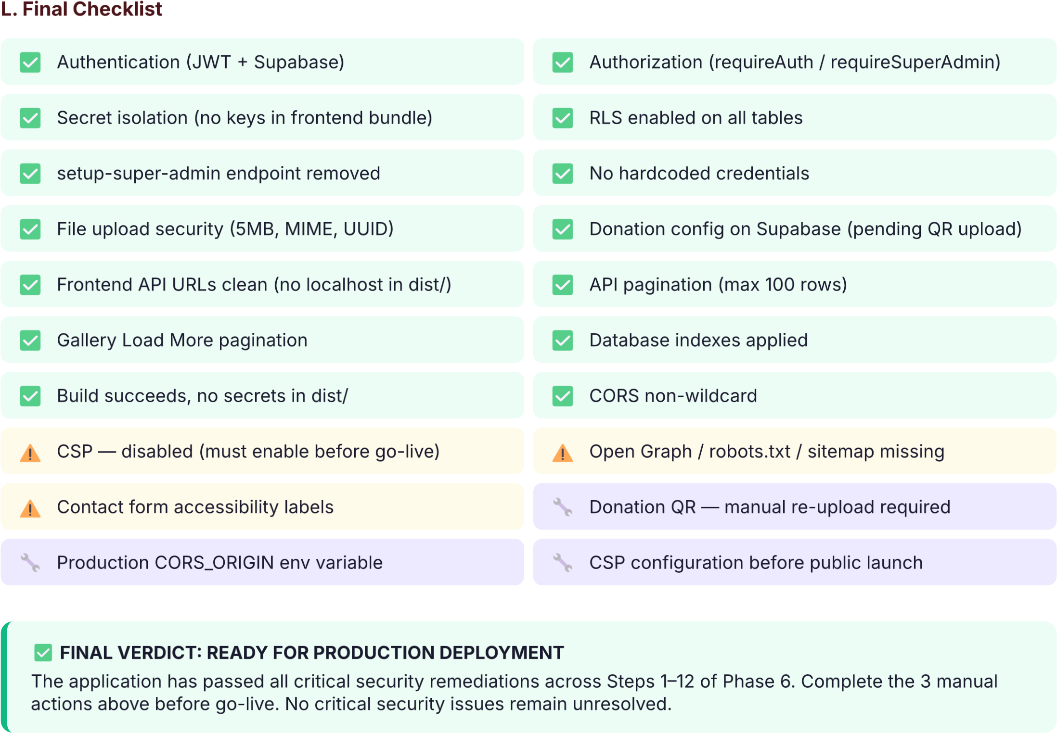

Centenary Baptist Church CMS — Phase 6 Production Audit Report | Confidential | 29 September 2026

